RC car Chassis Research
Edwin Mathew
The chassis (also known as the frame) is a vital component of a RC Car, as it is the foundation structure of which all the parts attach in some way, shape or form. The purpose of a chassis is to sustain the weight of the all the other parts in its dynamic state.
The handling of the RC Car can be affected due to the flex of the chassis. The chassis flex and the front-rear suspension stiffness will decide on how the weight is distributed to each tire. The chassis will twist, and the weight won’t transfer to the tires as expected if the chassis is too flexible. The suspension adjustment will then be less effective compared to a stiff chassis.
Thus, the material chosen to make is the chassis is extremely important as this can make or break the car. The material used to manufacture the chassis has their own strengths and weakness. The most common material used on RC Car chassis are:
- Moulded plastic/fibre-reinforced plastic
- Aluminium
- Woven carbon fibre
Before manufacturing a chassis, it is important to consider:
- The terrain the RC car is designed for.
- The durability for its purpose
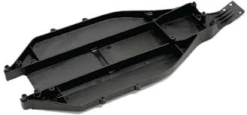
Plastic
When manufacturing chassis with plastic they are injection moulded, thus meaning complex shapes are able to be designed, cutting down the parts count of the kit. This material is durable, softest, allows the most amount of flex and are cheaper than the other materials.

References
Radio Control Car action, HOW TO: UNDERSTAND CHASSIS TECH,
https://www.rccaraction.com/understand-chassis-tech/#:~:text=The%20chassis%20is%20one%20of,you%20are%20doing%20is%20critical.

